Systems Design Document

UML Use Case Diagram

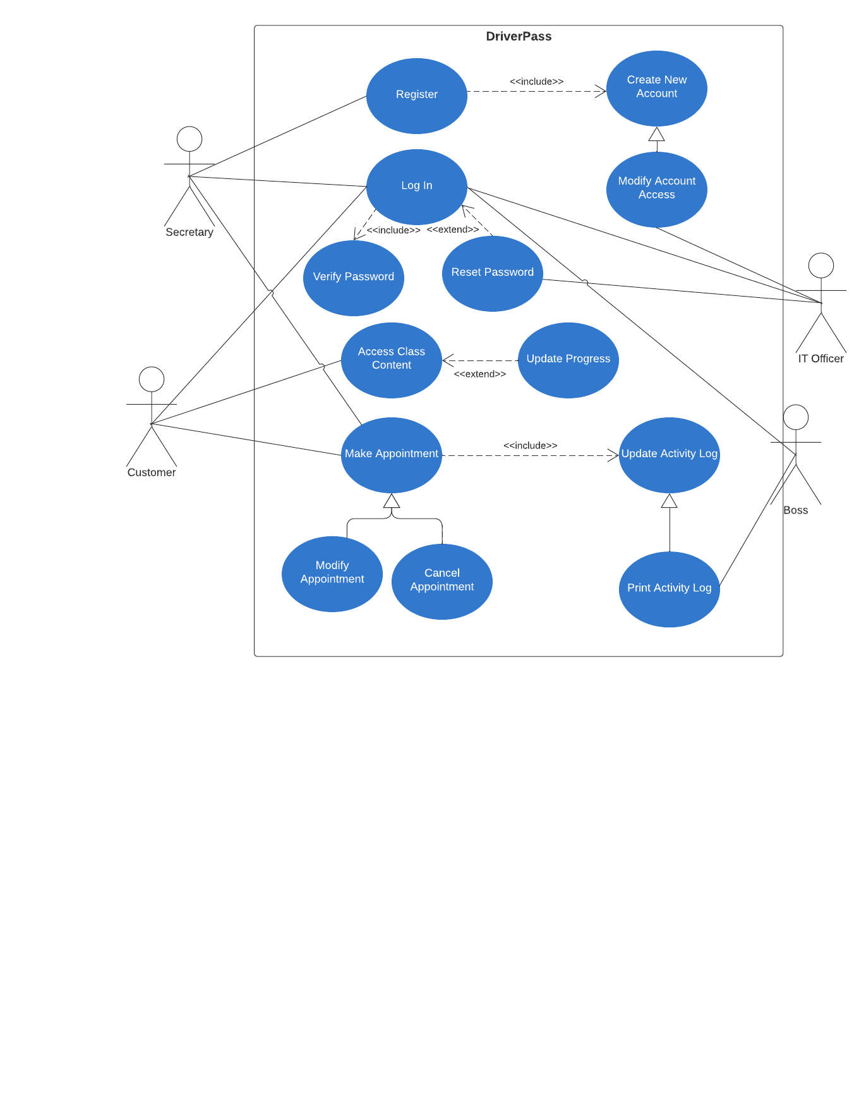

UML Activity Diagrams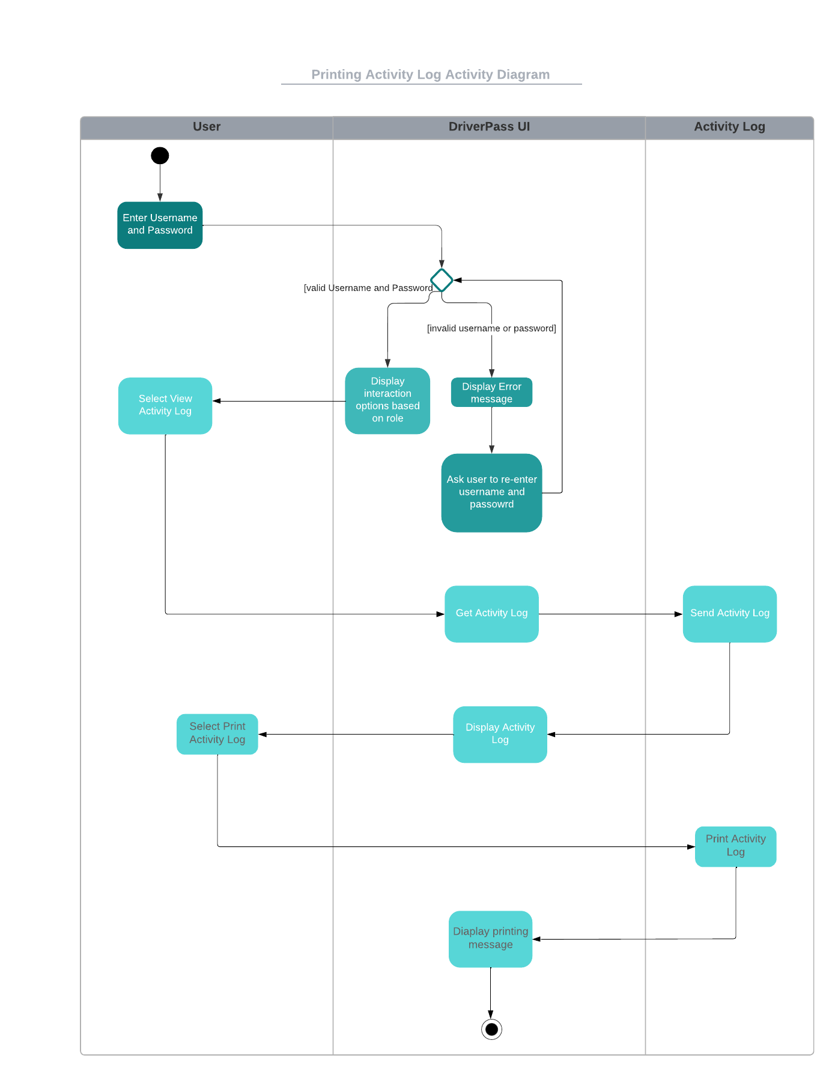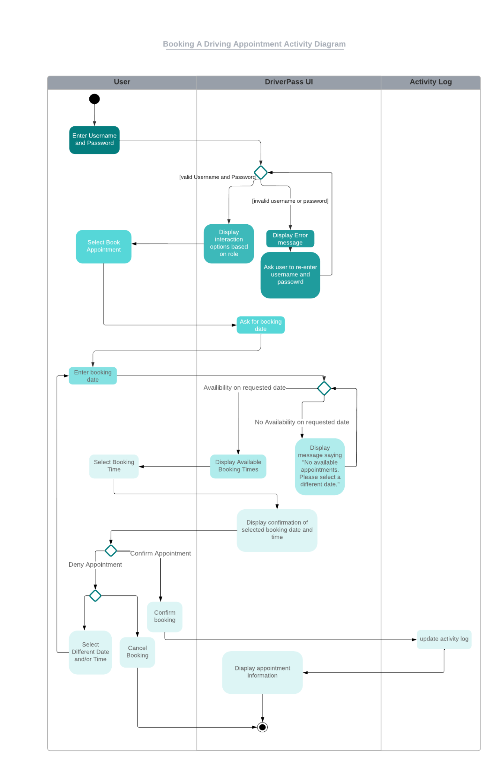

UML Sequence Diagram

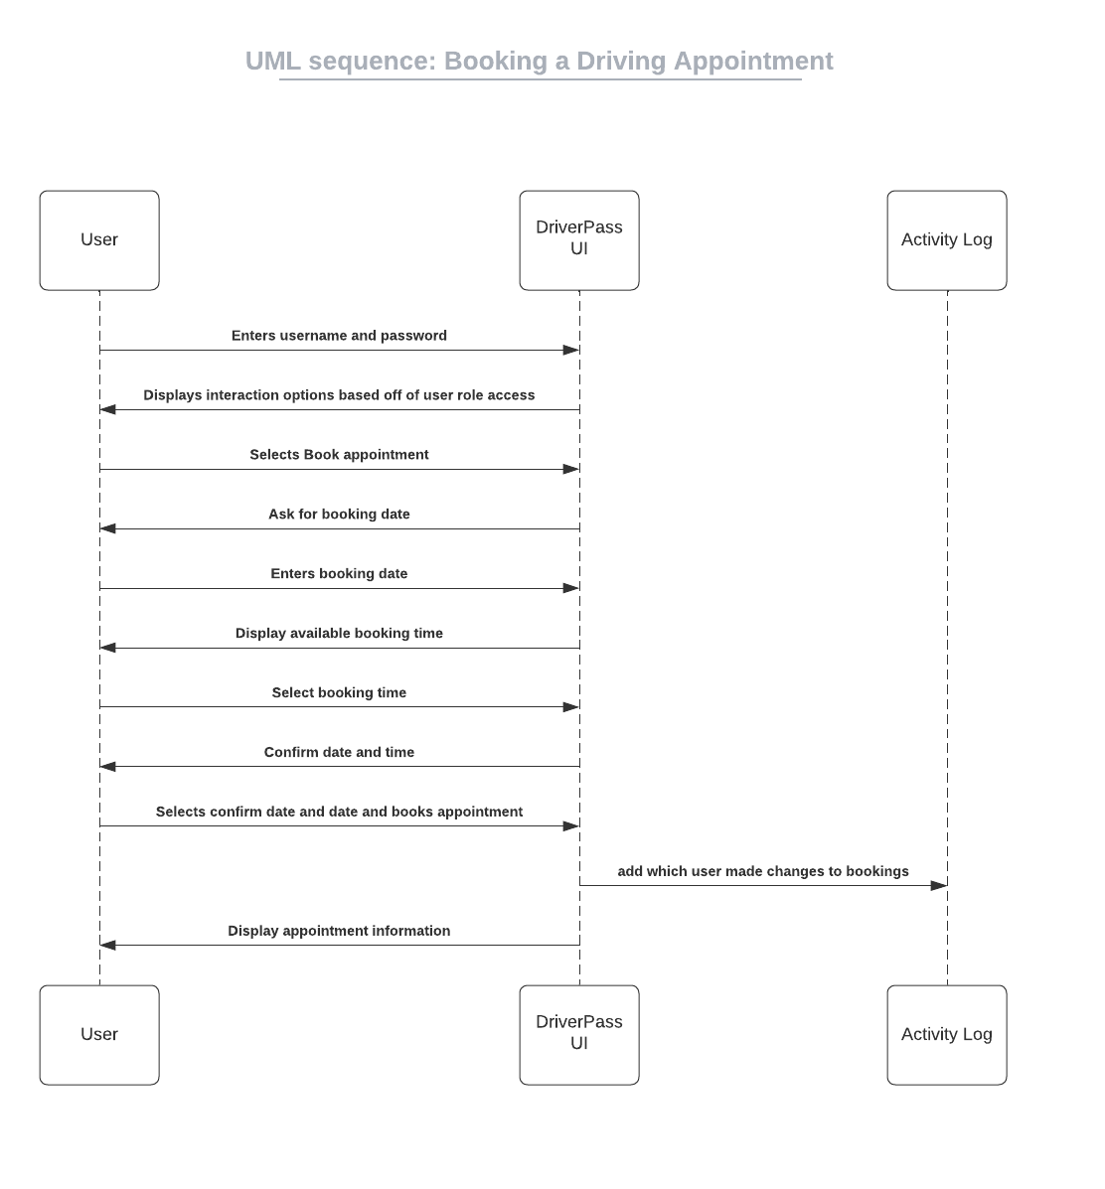

UML Class Diagram

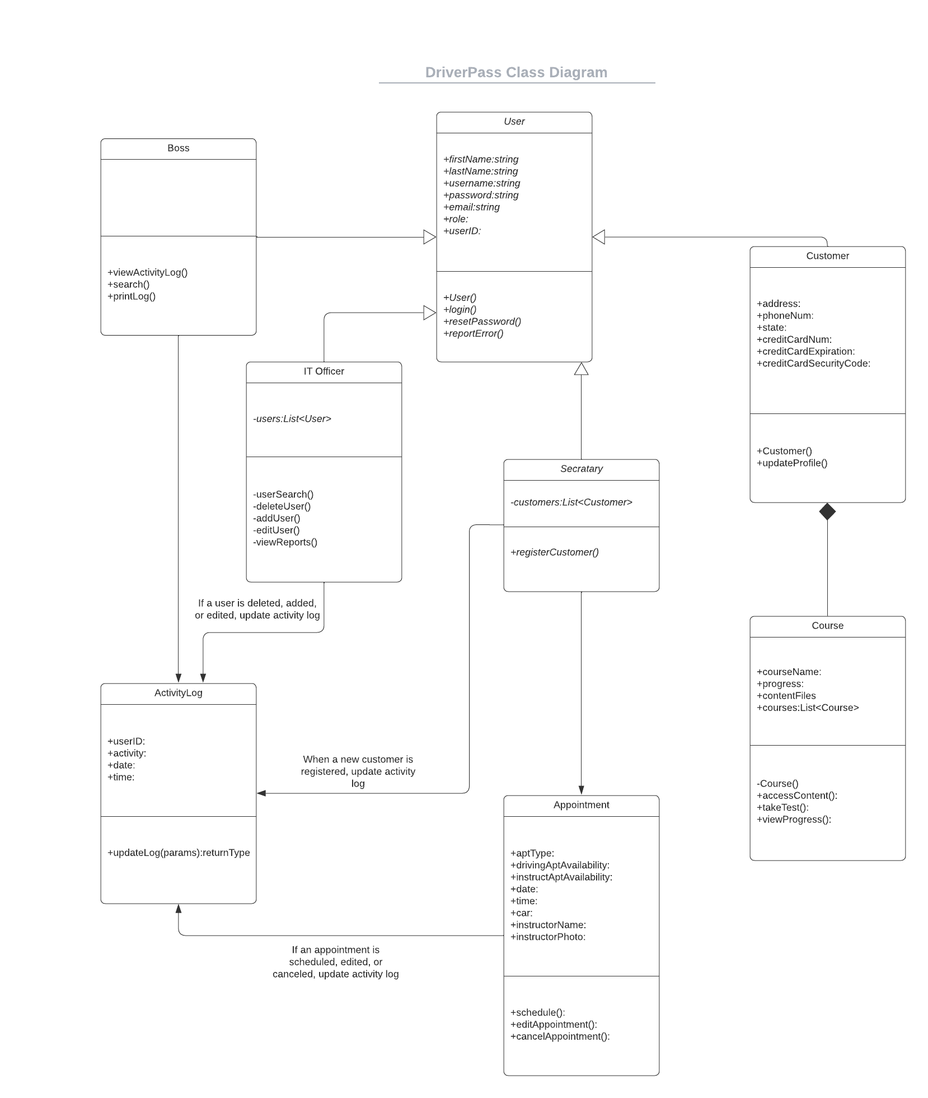

Technical Requirements

The system requires the user to have either a desktop or a mobile device. They will also need to have access to the internet. The system will be accessed through a web browser. There will need to be a built in bug reporting system so that the IT officer can be notified when users are having technical issues. The client does not want to handle security themselves so it has to be provided. Pages should load in less than 3 seconds and there should be instant response to user interaction. Passwords should be able to be reset automatically. Access should be limited by role. The system should be intuitive and easy to navigate.